Libraries included:-

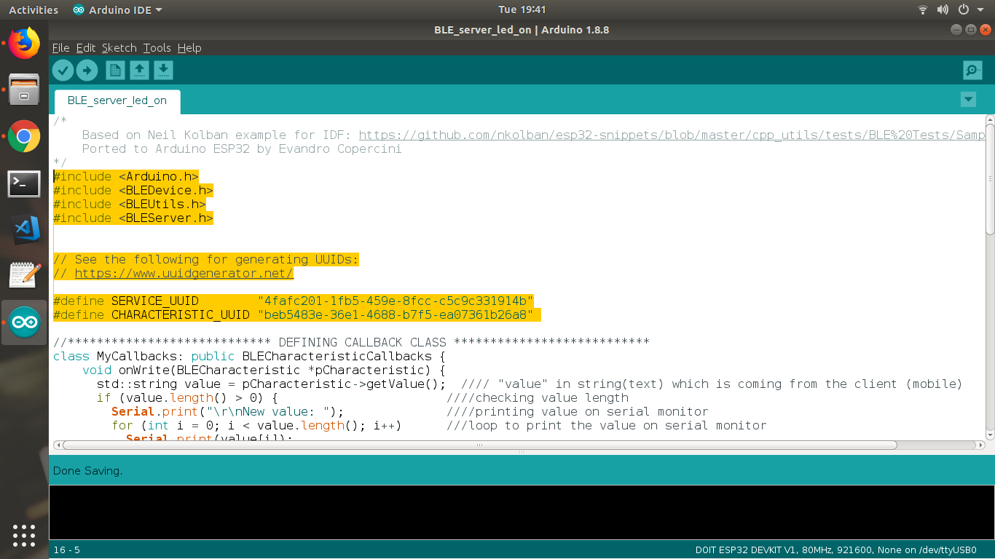

//\*\*\*\*\*\*\*\*\*\*\*\*\*\*\*\*\*\*\*\*\*\*\*\*\*\*\*\* DEFINING CALLBACK CLASS \*\*\*\*\*\*\*\*\*\*\*\*\*\*\*\*\*\*\*\*\*\*\*\*\*\*\*

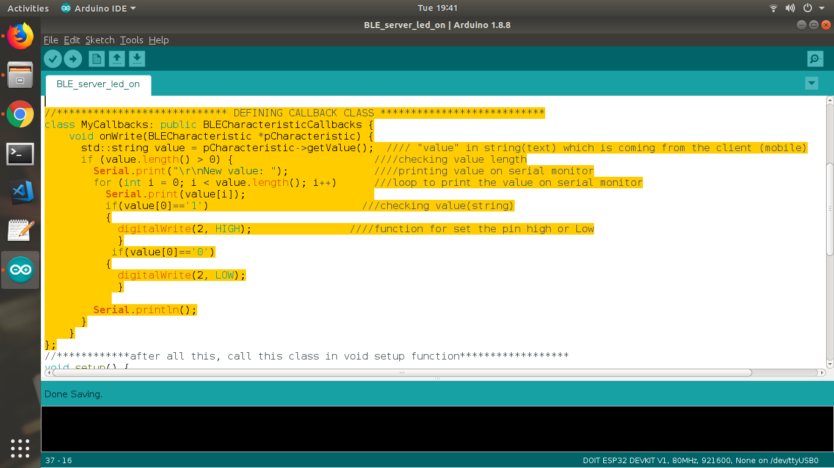

//\*\*\*\*\*\*\*\*\*\*\*\*after all this, call this class in void setup function\*\*\*\*\*\*\*\*\*\*\*\*\*\*\*\*\*\*

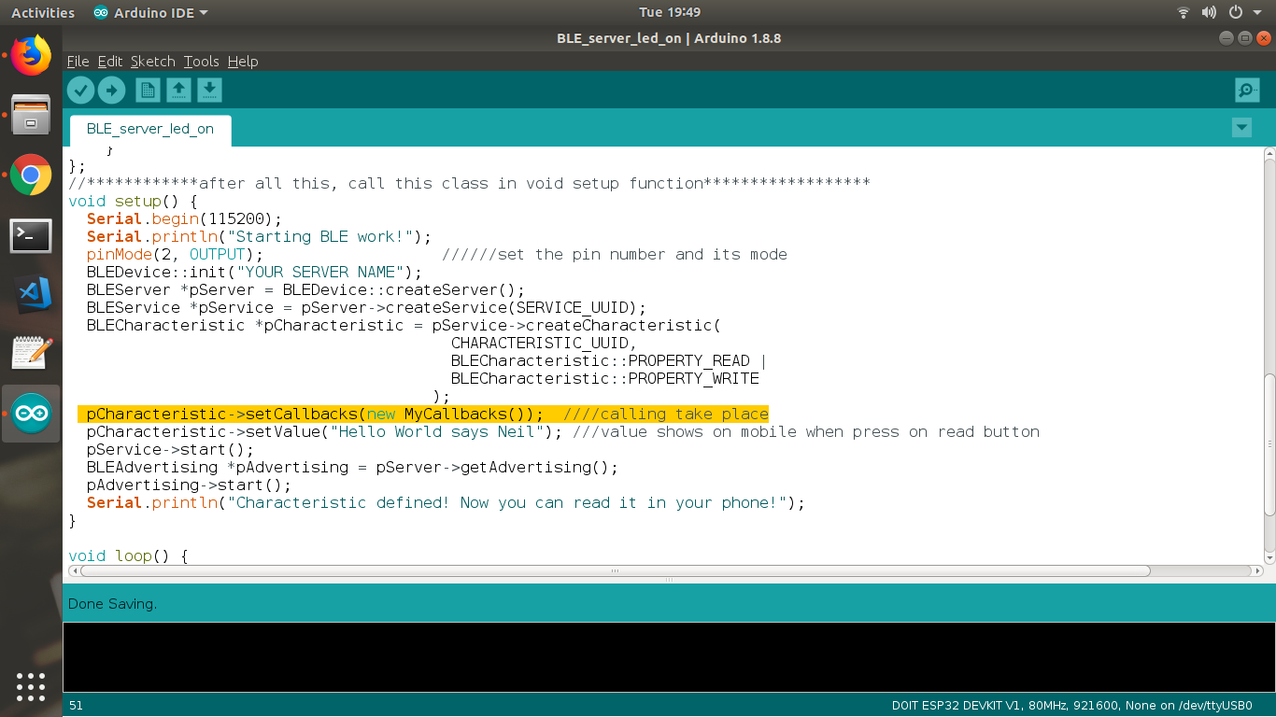

//\*\*\*\*\*\*\*\*\*\*\*\*\*\*\*\*\*\*\*\*\*\*\*\*\*\*\*\*void loop\*\*\*\*\*\*\*\*\*\*\*\*\*\*\*\*\*\*

void loop() {

//put your main code here, to run repeatedly:

delay(2000);

}

\*\*Verify and Compile this code to your ESP32.

\*\*open serial monitor.

\*\*press reset button.

**\*\* Open BleSERVER App in your mobile.**

**\*\*Connect to the server name...which you have provided in Code**

**\*\*press on CUSTOM SERVICE.**

**\*\*press on (w).**

**\*\*write 1 or 0 in text box.**

**\*\*click on send button.**

**\*\*\*you got your LED ON / OFF.**